Contents
Chapter 1: DVR Features 2
DVR Feature 2
Chapter 2: Overview 2
2.1 Front Panel 2
2.2 Rear Panel 3
2.3 Remote Control 4
Chapter 3: Installation 5
3.1 Install Hard Disk 5
3.2 Connecting Camera and Monitor 5
3.3 VGA Output (optional) 5
3.4 Connecting Power Supply 5
Chapter 4: Starting the DVR 5
4.1 Firmware Version 5
4.2 Detecting Installed Hard Drive 5
4.3 Format Hard Drive 6
Chapter 5: DVR Menu System 6
5.1 Navigating the Menus 6
5.2 Menu Overview 6
5.3 Camera Setup 7
5.4 Record Setup 7
5.5 Record Frame Rate 7
5.6 Video Quality 8
5.7 Record Schedule 8
5.8 Sensor Setup 9
5.9 H/W Sensor Setup 9
5.10 Motion Detector Setup 9
5.11 Hard Drive Setup 10
5.12 Miscellaneous Setup - Change Password 10
5.13 Miscellaneous Setup - Set Time 11
5.14 Miscellaneous Setup - Hidden Channel 11
5.15 Miscellaneous Setup - Audio Port Setup 11
5.16 Miscellaneous Setup - PTZ Setup 12
5.17 Miscellaneous Setup - Image Parameters 12
5.18 Miscellaneous Setup - Password Enable 13
5.19 Miscellaneous Setup - Keypad Tones 13
5.20 Miscellaneous Setup - Sequence Dwell Time 13
5.21 Miscellaneous Setup - VGA Setup 14
5.22 Network Setup 14
5.23 Language 17
5.24 Video Backup 17
5.25 Reset Menu 19
5.26 NTSC/PAL Output select 19
Chapter 6: Record 20
6.1 Start Recording 20
6.2 Audio Recording 20

6.3 Stop Recording 21
6.4 Estimated Recording Length 21
Chapter 7: Playback 21
Chapter 8: USB Progamming 22
8.1 Driver Installation: 22
8.2 Program Interface – Button Functions: 22
8.3 Program Running 23
8.3.1 HDD play mode 23
8.3.2 FILE play mode 24
8.3.3 NET play mode 24
Chapter 9: Specification 25
Chapter 10: Appendix 26
10.1 System connection diagram 26
10.2 Accessories 26

Chapter 1: DVR Features

DVR Feature
- MPEG-4 compression
- 4-Channel: 4 BNC Camera Inputs - 2 BNC Video Outputs
9-Channel: 9 BNC Camera Inputs - 1 BNC Video Output
4-Channel: 2 Audio Inputs - 2 Audio Outputs
9-Channel: 1 Audio Input -1 Audio Output
- System Format : NTSC /PAL
- Motion Detection with Sensitivity and Area Settings
- Time Schedule, Alarm and Motion Triggered Recording Modes
- Hard Disk Support up to 500GB
- Supports PTZ Control via RS-485 Port
- View and Operate over Network (Broadband Connection Required)
- Built-in USB 2.0 Port for Backup to Computer or USB Memory Stick Backup (Optional)
- VGA Output (Optional)

Chapter 2: Overview

2.1 Front Panel
2.1.1 4-ch DVR front panel
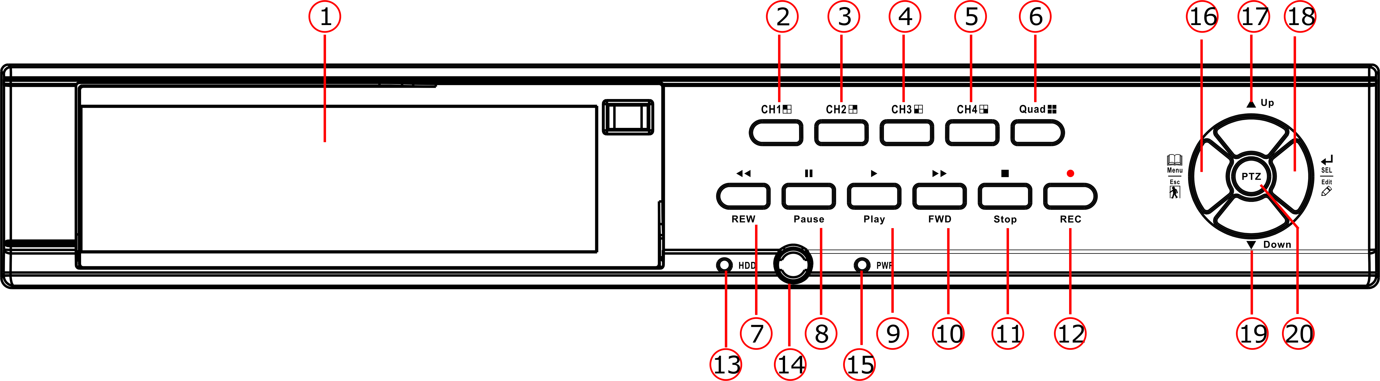

- Removable HDD Tray
- CH1
- CH2
- CH3
- CH4
- QUAD: View all channels
- REW: Rewind play/Focus
- PAUSE: Pause/Auto sequence display
- PLAY: Play recorded file/Zoom
- FWD : Forward play/Iris
- STOP
- REC
- HDD LED
- IR Receiver
- Power LED
16. MENU/ESC/LEFT
17. UP
18. SEL/EDIT/RIGHT
19. DOWN
20. PTZ: Enter PTZ mode

2.1.2 9-ch DVR front panel
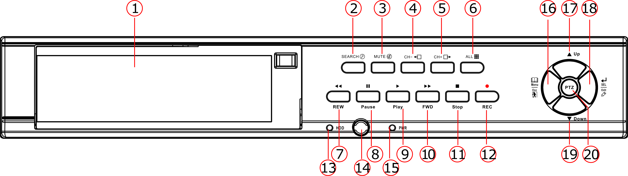

- Removable HDD Tray
- SEARCH
- MUTE: Turn on/off audio output
- CH-: View previous channel
- CH+: View next channel
- ALL: View all channels
- REW: Rewind play/Focus
- PAUSE: Pause/Auto sequence display
- PLAY: Play recorded file/Zoom
- FWD：Forward play/Iris
- STOP
- REC: Record
- HDD LED
- IR receiver
- Power LED
- MENU/ESC/LEFT
- UP
- SEL/EDIT/RIGHT
- DOWN
- PTZ: Enter PTZ mode

2.2 Rear Panel
2.2.1 4-ch DVR real panel
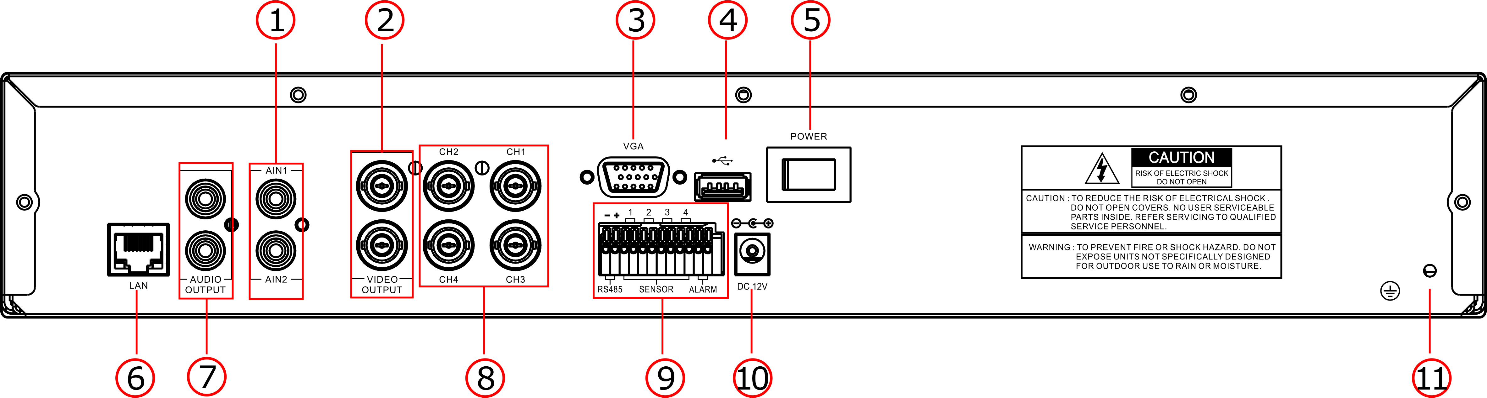

- Audio inputs
- Video outputs
- VGA output (Optional)
- USB port
- POWER Switch
- LAN: Ethernet port
- Audio outputs
- CH1-CH4：Video input1- video input4
- RS-485/SENSOR/ALARM
- DC Power Input Jack
- Grounding

2.2.2 9-ch DVR rear panel
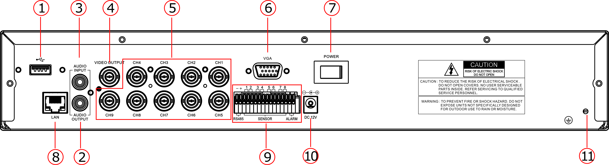

- USB port
- Audio output
- Audio input
- Video output
- CH1-CH9：Video input1- video input9
- VGA output (Optional)
- POWER Switch
- LAN: Ethernet port
- RS-485/Sensor/Alarm
- DC Power input jack
- Grounding

2.3 Remote Control
1-9 | Channel Select 1-4/9
0 | Number
ALL | Display all Channels
Menu | Enter or Exit Menu
▲ | Move Up
▼ | Move Down
◄ / ► | Left/ Right
SEL | Select /Modify Item
 | Rewind/Focus
 | Play Recording/Zoom
 | Fast Forward/Iris
● | Record
 | Pause/Auto sequence display
■ | Stop Recording/Playback
Audio/Search | Search (9-ch)or switch the audio channels(4-ch)
Mute | Turn on/off audio output
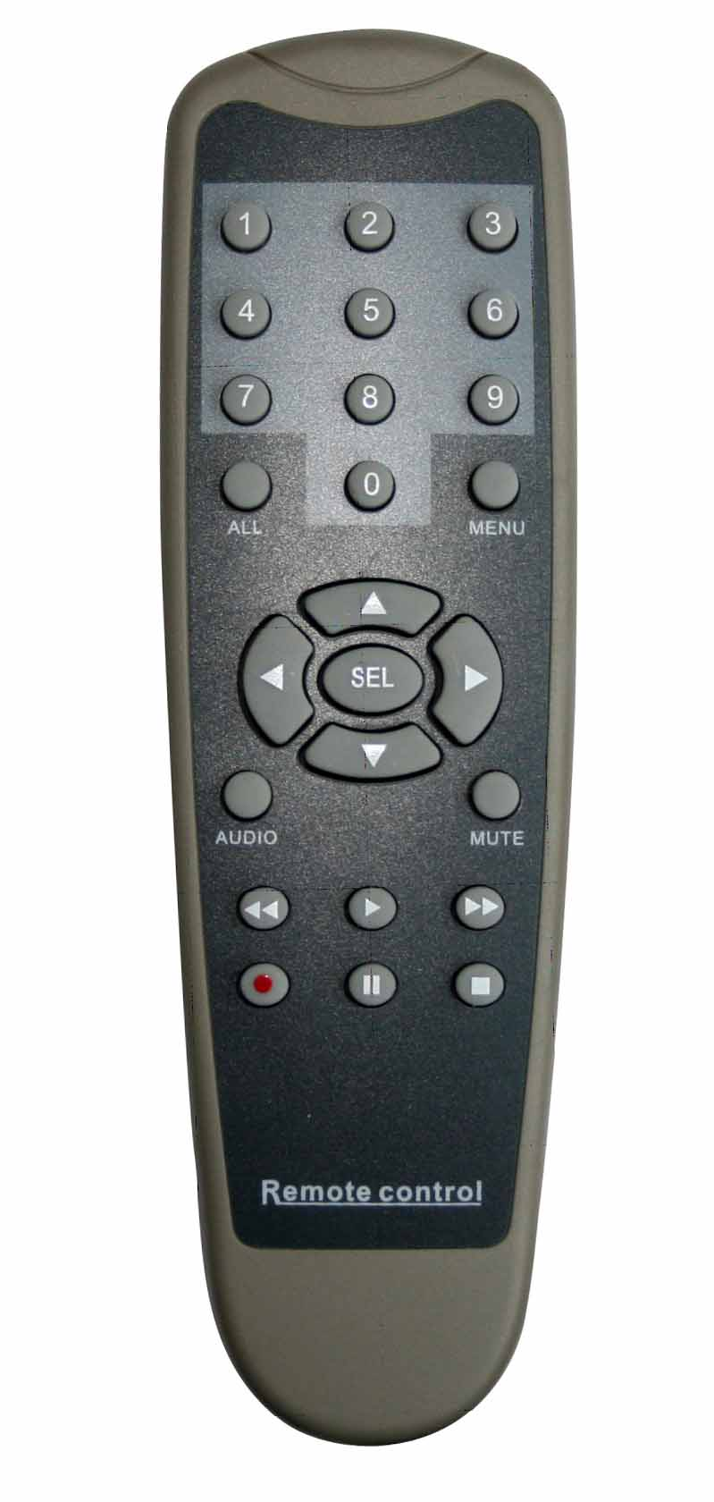

Chapter 3: Installation

3.1 Install Hard Disk
NOTICE: Don’t take out HDD when DVR is running.
(1) Take out the Hard Disk Drive tray carefully.
(2) Connect the power cord and data cable to hard disk carefully.
(3) Put the Hard Disk Drive tray back into the DVR and then lock the HDD tray.

3.2 Connecting Camera and Monitor
There are 4/9 camera inputs and 2/1 Monitor outputs with BNC connectors (Refer to 2.2 Rear Panel).

3.3 VGA Output (optional)
There is 1 CRT or LCD monitor output with VGA port.

3.4 Connecting Power Supply
Please only use the power adapter supplied with the DVR.

Chapter 4: Starting the DVR

4.1 Firmware Version
After connecting the power adapter and turning on the power button, the system will boot-up and display the version and released date of the DVR firmware.

V1.9
V-EN-BG
2008.2.23

4.2 Detecting Installed Hard Drive
DVR will detect the installed hard drive and display the hard drive information.

CHECKING HDD……

MASTER [WDC WD3200AAJB-00T]
SLAVE……

4.3 Format Hard Drive
When the DVR detects a new hard drive, you will be prompted to format the hard drive before using the DVR.
Press [SEL] to format or press [MENU] to cancel.

CHECKING HDD……
MASTER [WDC WD3200AAJB-00T]-NEW-DVR FORMAT HDD CONFIRM
(SELECT) FORMAT / (MENU) CANCEL?

Chapter 5: DVR Menu System

5.1 Navigating the Menus
Press [MENU] to enter Main Menu
Press [▲, ▼, and ] to move the cursor
Press [SEL] to select/modify settings
Press [MENU] again to exit or go back to previous menu.
MAIN MENU

CAMERA SETUP
RECORD SETUP
RECORD FRAMERATE
VIDEO QUALITY NORMAL
RECORD SCHEDULE
SENSOR SETUP
HARD DRIVE SETUP
MISCELLANEOUS SETUP
NETWORK SETUP
LANGUAGE ENGLISH
VIDEO BACKUP
RESET MENU

( ) MOVE (SEL)SELECT (MENU)EXIT

( )MOVE (SEL)SELECT (MENU)EXIT

5.2 Menu Overview
Menu Directory
Camera Setup
Record Setup
Record Frame rate
Change Password
Set Time
Hidden Channel
Audio Port Setup
PTZ Setup
Image Parameters
Password Enable
Keypad Tones
Seq. Dwell Time
VGA Setup

Video Quality
Record Schedule
Sensor Setup
Main Menu
Hard Drive Setup
Miscellaneous Setup
Network Setup
Language
Video Backup
Reset Menu

5.3 Camera Setup
Camera Setup allows you to turn cameras on or off.
Press [▲, ▼, ◄◄ and ►►] buttons to select a channel and then press [SEL] to modify the setting ON or OFF.
1 ON 2 ON
CAMERA SETUP

3 ON 4 ON

( )MOVE (SEL) SELECT (MENU)EXIT

Note：If a camera channel is set to OFF, it will not be recorded (Refer to 6.4 Record Setup)

5.4 Record Setup
Record Setup allows you to set up recording channels.
Press [▲, ▼, ◄◄and ►►] buttons to select a channel, and then press [SEL] to modify the setting to ON or OFF.
If a channel is disabled in Camera Setup, it will not record and the DVR will display “NOCAM” on screen.
1 ON 2 NOCAM
RECORD SETUP

3 ON 4 ON

( )MOVE (SEL) SELECT (MENU)EXIT

5.5 Record Frame Rate
The total frame rate is 50fps (PAL) or
60fps (NTSC). You can set the frame rate for the channel which you select to record. If the sum of the frame rate you select for all cameras is more than 50fps (PAL)/60fps(NTSC), the DVR will automatically adjust the largest frame rate value to a smaller value.
1 3FPS 2 5FPS
RECORD FRAMERATE
TOTAL 36FPS

3 25FPS 4 3FPS

( )MOVE (SEL) + ( ■ )- (MENU)EXIT

Press [▲, ▼, ◄◄or ►►] button to select a channel, and then press [SEL] to increase the value or press [■STOP] to reduce the value.
Note: Higher frame rate shows smooth images, but requires more hard drive space.

5.6 Video Quality
Video Quality has 4 different settings: Highest, High, Normal and Low.
The higher the video quality, the better quality of images, however higher quality images require more hard drive space.
Press [SEL] to change the quality setting.

MAIN MENU

CAMERA SETUP
RECORD SETUP
RECORD FRAMERATE
VIDEO QUALITY NORMAL
RECORD SCHEDULE
SENSOR SETUP
HARD DRIVE SETUP
MISCELLANEOUS SETUP
NETWORK SETUP
LANGUAGE ENGLISH
VIDEO BACKUP
RESET MENU

( )MOVE (SEL)SELECT (MENU)EXIT

( )MOVE (SEL)SELECT (MENU)EXIT

5.7 Record Schedule
Setting the Record Schedule allows you to customize the type of recording depending on the time of day.
The time line indicates 24 hours of a day based on AM/PM (0 = 12).
Press [▲, ▼, ◄◄ or ►►] button to select a time point, press [SEL] to modify the recording mode.
RDCORD SCHEDULE

AM PM
0… 3… 6… 9… 0… 3…. 6… 9…

NO-RECORD
NORMAL-RECORD
SENSOR-RECORD

( )MOVE (SEL)SELECT (MENU)EXIT

S

NO-RECORD [white]: DVR will not record during the time.
NORMAL-RECORD [red]: DVR will record continuously.
SENSOR-RECORD [S]: DVR will record when sensor or motion is triggered.
NOTE: In order to activate the record schedule, press the [] record button when viewing the cameras. After pressing the [] record button, if schedule is set to “NORMAL-RECORD” , the DVR will start to record immediately; if the schedule is set to be “SENSOR-RECORD” , the DVR will not start recording until a motion is detected by the DVR or an installed sensor is triggered.

5.8 Sensor Setup
Sensored Record Time indicates how long the recording time is when the motion or sensor is triggered.
Alarm On Time indicates whether the buzzer will sound when motion is detected.

SENSORED RECORD TIME:
The number (5,10,15,20,25,30) indicates how many seconds the motion detection or sensor triggered recording lasts after motion or sensor triggering stop.
ALARM ON TIME:
This selection indicates how many seconds the buzzer inside the DVR or extension alarm sounds after motion or sensor triggering stop.

SENSOR SETUP

SENSORED RECORD TIME 30
ALARM ON TIME OFF

H/W SENSOR SETUP
MOTION DETECTOR SETUP

( )MOVE (SEL)SELECT (MENU)EXIT

CONT: Continuous alarm until any key is pressed.
OFF: No alarm
Note: Sensored Record Time and Alarm On Time are measured in seconds

5.9 H/W Sensor Setup
Note: Sensors and extension alarm are not included with the DVR system and may be purchased separately.
Hardware Sensor Setup:
There are 3 different modes for sensor setting: NOT INSTALLED, NORMAL-CLOSE and NORMAL-OPEN. Consult the alarm purchased for more details on which setting is required.

H/W SENSOR SETUP

CHANNEL-1 TYPE:NORMAL-OPEN
CHANNEL-2 NOT INSTALLED
CHANNEL-3 NOT INSTALLED
CHANNEL-4 NOT INSTALLED

( )MOVE (SEL)SELECT (MENU)EXIT

Note: For 4-ch DVR, there are 4CH inputs of the sensor
For 9-ch DVR, there are 8CH inputs of the sensor

5.10 Motion Detector Setup
This section allows you to set up motion detection options for each camera.
Motion Detector Setup:
ON/OFF: Enable or disable motion detection recording.
LEVEL: Sensitivity for motion detection. There are 3 levels sensitivity: Level 1-low, level 3- highest
AREA: Select detectable area on the screen.

MOTION DETECTOR SETUP

CH1 ON LEVEL1 AREA
CH2 ON LEVEL2 AREA
CH3 ON LEVEL2 AREA
CH4 ON LEVEL2 AREA

( )MOVE (SEL)SELECT (MENU)EXIT

Area Selection:
Press [▲, ▼, ◄◄ or ►►] button to select a block, and press [SEL] button to set the block to detect motion. The area is detectable when it is clear, the area is not detectable when it is covert by shadow.

Press “Stop” button to disable all areas, press “Quad” or “ALL” button to enable all areas.

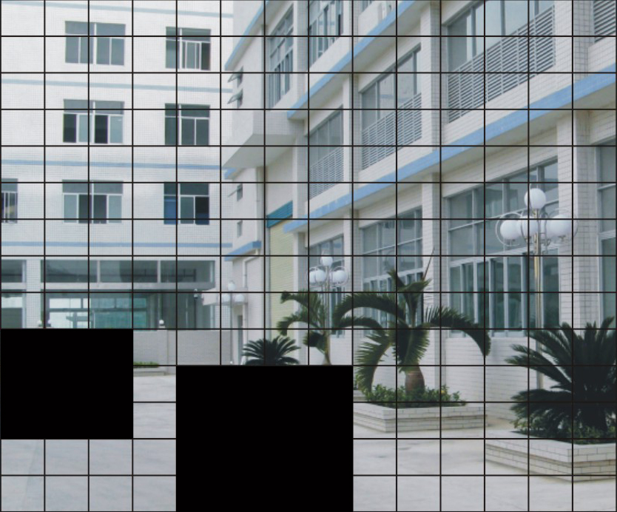

5.11 Hard Drive Setup
This section will display the current hard drive status and usage options
HARD DRIVE SETUP

OVERWRITE ENABLED [ ON ]
ST3160215A
MASTER HDD SIZE 160133MB
MASTER HDD USED 124931MB 78%
MASTER HDD FORMAT

SLAVE HDD SIZE N/A
SLAVE HDD USED N/A
SLAVE HDD FORMAT

( )MOVE (SEL)SELECT (MENU)EXIT
Overwrite Enabled:
ON: Overwrite oldest video when hard drive is full.
OFF: Stop recording when hard drive is full.

HDD SIZE: Indicates the total capacity of the hard drive installed in the DVR.
HDD USED: Indicates the space used in the hard disk drive for recording and the percent used.
HDD FORMAT: Will erase all video and data on the installed hard drive and make it readable by the DVR
Note: You will be prompted for the password when formatting a hard drive. The default password is “111111”

5.12 Miscellaneous Setup - Change Password
MISCELLANEOUS SETUP

CHANGE PASSWORD
SET TIME
HIDDEN CHANNEL
AUDIO PORT SETUP
PTZ SETUP
IMAGE PARAMETERS
PASSWORD ENABLE
KEYPAD TONES
SEQ. DWELL TIME
VGA SETUP
( )MOVE (SEL)SELECT (MENU)EXIT

( )MOVE (SEL)SELECT (MENU)EXIT
[ 4 ]

[ CH4 ]
[ OFF ]
[ ON ]
[ 05 ]
[1024*768 75HZ]
This option allows you to change the system password. The password must be composed with six characters.
All keys can be used as password key except the [MENU] key, which is used to exit.

Enter the current password first, and then enter six characters as your new password, repeat the new password to confirm.
If you forget your password, please contact technical support for assistance.

CURRENT PASSWORD
NEW PASSWORD
CONFIRM PASSWORD

[- - - - -]
[- - - - -]
[- - - - -]

5.13 Miscellaneous Setup - Set Time
The system date and time format is YYYY/MM/DD and HH:MM: SS.
Press [◄◄] or [►►] button to select the data to modify, press [SEL] to modify. Press [MENU] to save and return to previous menu.
SET TIME

2008/11/11 17:50:01

( )MOVE (SEL)SELECT (MENU)EXIT

5.14 Miscellaneous Setup - Hidden Channel
The system provides a function to hide a channel in monitoring mode. The selected channel can still be recorded while it’s hidden; the hidden picture is viewable during playing back.
Press [SEL] to select a channel to hide.
MISCELLANEOUS SETUP

CHANGE PASSWORD
SET TIME
HIDDEN CHANNEL
AUDIO PORT SETUP
PTZ SETUP
IMAGE PARAMETERS
PASSWORD ENABLE
KEYPAD TONES
SEQ。DWELL TIME
VGA SETUP
( )MOVE (SEL)SELECT (MENU)EXIT

( )MOVE (SEL)SELECT (MENU)EXIT

[ 4 ]

[ CH4 ]
[ OFF ]
[ ON ]
[ 05 ]
[1024*768 75HZ]

5.15 Miscellaneous Setup - Audio Port Setup
You can select the audio recording function to ON or OFF, and select the video channel that you like to record the audio on.
AUDIO PORT SETUP

AUDIO PORT1-VIDEIO CHANNEL
AUDIO PORT1-RECORD
AUDIO PORT2-VIDEO CHANNEL
AUDIO PORT2-RECORD

( )MOVE (SEL)SELECT (MENU)EXIT
[ 1 ]
[ OFF ]
[ 2 ]
[ ON ]

Note: For 4-ch DVR, there are 2 audio inputs.
For 9-ch DVR, there is only 1 audio input.

5.16 Miscellaneous Setup - PTZ Setup
SPEED: Set the baud rate (2400,4800，9600，19200，38400) to match your speed dome.
PROTOCOL: Supports “PELCO-D” and “PELCO-P”. Select the protocol according to your speed dome’s protocol.
CAMERA: Select the camera channel which is connected with the speed dome.

PTZ SETUP

SPEED [4800]
PROTOCOL [PELCO-D]
CAMERA- [ 1 ] ID [ 1 ]

( )MOVE ( )CAM ID
(SEL)SELECT (MENU)EXIT

ID: Assign an ID to your speed dome.
Press [SEL] to select the camera, press [ ] and [ ] buttons to assign the ID.
Note: the ID must be unique.

5.17 Miscellaneous Setup - Image Parameters
You can adjust the image parameters according to your needs.
Move the cursor to this selection and press [] or [ ] button to select a channel you want to adjust, then press [SEL] button to edit parameters.
MISCELLANEOUS SETUP

CHANGE PASSWORD
SET TIME
HIDDEN CHANNEL
AUDIO PORT SETUP
PTZ SETUP
IMAGE PARAMETERS
PASSWORD ENABLE
KEYPAD TONES
SEQ. DWELL TIME
VGA SETUP
( )MOVE (SEL)SELECT (MENU)EXIT

( )MOVE (SEL)SELECT (MENU)EXIT

[ 1 ]

[ CH3 ]
[ OFF ]
[ ON ]
[ 05 ]
[1024*768 75HZ]

CON: Contrast
BRI: Brightness
HUE: Hue
SAT: Saturation
Press [▲] or [▼] to select the item， and then press [ ] and [ ] buttons to adjust the value.
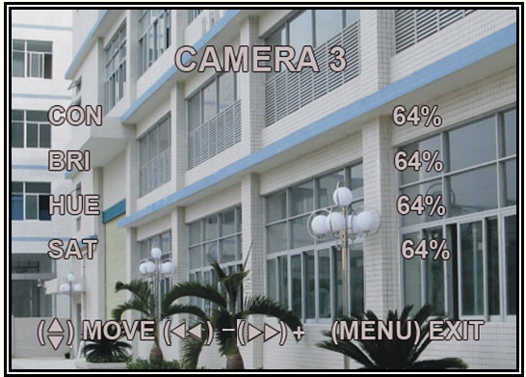

5.18 Miscellaneous Setup - Password Enable
The password will be required to control the DVR when this option is set to “ON”, and the password is not required when this option is set to “OFF”.

MISCELLANEOUS SETUP

CHANGE PASSWORD
SET TIME
HIDDEN CHANNEL
AUDIO PORT SETUP
PTZ SETUP
IMAGE PARAMETERS
PASSWORD ENABLE
KEYPAD TONES
SEQ.DWELL TIME
VGA SETUP
( )MOVE (SEL)SELECT (MENU)EXIT

( )MOVE (SEL)SELECT (MENU)EXIT

[ 1 ]

[ CH3 ]
[ OFF ]
[ ON ]
[ 05 ]
[1024*768 75HZ]

5.19 Miscellaneous Setup - Keypad Tones
This function allows you to enable /disable buzzer sound when pressing a button. Press [SEL] to select ON or OFF.
MISCELLANEOUS SETUP

CHANGE PASSWORD
SET TIME
HIDDEN CHANNEL
AUDIO PORT SETUP
PTZ SETUP
IMAGE PARAMETERS
PASSWORD ENABLE
KEYPAD TONES
SEQ. DWELL TIME
VGA SETUP
( )MOVE (SEL)SELECT (MENU)EXIT

( )MOVE (SEL)SELECT (MENU)EXIT
[ 4 ]

[ CH4 ]
[ OFF ]
[ ON ]
[ 05 ]
[1024*768 75HZ]

5.20 Miscellaneous Setup - Sequence Dwell Time
This function allows you to set the dwell time for each camera when you enable the auto sequence display function.
Press [◄◄] and [►►] buttons to adjust the value.
MISCELLANEOUS SETUP

CHANGE PASSWORD
SET TIME
HIDDEN CHANNEL
AUDIO PORT SETUP
PTZ SETUP
IMAGE PARAMETERS
PASSWORD ENABLE
KEYPAD TONES
SEQ.DWELL TIME
VGA SETUP
( )MOVE (SEL)SELECT (MENU)EXIT

( )MOVE (SEL)SELECT (MENU)EXIT
[ 4 ]

[ CH4 ]
[ OFF ]
[ ON ]
[ OFF]
[1024*768 75HZ]

After setting, press [ ] button to turn on auto-sequence display function and then there’s a “SEQ”symbol displayed on the right top of screen. Press [ ] again to turn off this function in preview mode

5.21 Miscellaneous Setup - VGA Setup
Select a VGA resolution to match your CRT or LCD monitor.
NOTE: VGA video output is an optional function and may not be available on all models.

MISCELLANEOUS SETUP

CHANGE PASSWORD
SET TIME
HIDDEN CHANNEL
AUDIO PORT SETUP
PTZ SETUP
IMAGE PARAMETERS
PASSWORD ENABLE
KEYPAD TONES
SEQ. DWELL TIME
VGA SETUP
( )MOVE (SEL)SELECT (MENU)EXIT

( )MOVE (SEL)SELECT (MENU)EXIT

[ 4 ]

[ CH4 ]
[ OFF ]
[ ON ]
[ 05 ]
[1024*768 75HZ]

5.22 Network Setup
Network Setup allows you to prepare the DVR for viewing over the internet or local network.
MAC ADDRESS: In a local area network(LAN)，the MAC (Media Access Control) address is your computer’s unique hardware identity code(On an Ethernet LAN，it is the same as your Ethernet address).When you are connected to the Internet from your computer (or host as the Internet protocol thinks of it )，a corresponding table relates your IP address to your computer’s physical (MAC) address on the LAN.
NETWORK SETUP

MAC ADDRESS
IP ALLOCATION
IP ADDRESS
SUBNET MASK
GATEWAY
DNS1 ADDRESS
DNS2 ADDRESS
HTTP PORT
USER SETUP
DDNS SETUP

(HTTP PORT) 80, 1024-49151
( )MOVE (SEL)SELECT (MENU)EXIT
<00:11:22:33:44:55>
[STATIC]
[192.168.1.100]
[255.255.255.0]
[192.168.1.1]
[0.0.0.0]
[0.0.0.0]
[ 80]

IMPORTANT: This setting should only be changed if multiple DVRs are being setup on the same network and the first code “00” must not to be changed.
NETWORK SETUP

MAC ADDRESS
IP ALLOCATION
IP ADDRESS
SUBNET MASK
GATEWAY
DNS1 ADDRESS
DNS2 ADDRESS
HTTP PORT
USER SETUP
DDNS SETUP

(HTTP PORT) 80, 1024-49151
( )MOVE (SEL)SELECT (MENU)EXIT
<00:11:22:33:44:55>
[STATIC]
[192.168.1.100]
[255.255.255.0]
[192.168.1.1]
[0.0.0.0]
[0.0.0.0]
[ 80]

IP ALLOCATION: DVR supports DHCP and Static IP modes. If your modem/router supports DHCP function, you can use DHCP mode. When using STATIC mode, you will be required to setup your IP settings manually.

Note: After setting the DVR to DHCP mode restart the unit.

NETWORK SETUP

MAC ADDRESS
IP ALLOCATION
IP ADDRESS
SUBNET MASK
GATEWAY
DNS1 ADDRESS
DNS2 ADDRESS
HTTP PORT
USER SETUP
DDNS SETUP

(HTTP PORT) 80, 1024-49151
( )MOVE (SEL)SELECT (MENU)EXIT
<00:11:22:33:44:55>
[STATIC]
[192.168.1.100]
[255.255.255.0]
[192.168.1.1]
[0.0.0.0]
[0.0.0.0]
[ 80]

IP Address: In a local network, the IP address is a unique designated address for your DVR recognized by your router. Ensure this number is within the range usable by your modem/router. Use the UP “▲” and DOWN “▼” buttons to move the cursor and use the “SELECT” button to change the numbers. Once you have finished the changes restart your DVR.

NETWORK SETUP

MAC ADDRESS
IP ALLOCATION
IP ADDRESS
SUBNET MASK
GATEWAY
DNS1 ADDRESS
DNS2 ADDRESS
HTTP PORT
USER SETUP
DDNS SETUP

(HTTP PORT) 80, 1024-49151
( )MOVE (SEL)SELECT (MENU)EXIT
<00:11:22:33:44:55>
[STATIC]
[192.168.1.100]
[255.255.255.0]
[192.168.1.1]
[0.0.0.0]
[0.0.0.0]
[ 80]

SUBNET MASK: Subnet Mask is used to determine what subnet an IP address belongs to. A number that is used to identify a sub network so that IP addresses can be recognized on a local area network. Consult your modem/router for your LAN’s subnet mask.

GATEWAY: Set this number to the gateway set by your modem/router.

NETWORK SETUP

MAC ADDRESS
IP ALLOCATION
IP ADDRESS
SUBNET MASK
GATEWAY
DNS1 ADDRESS
DNS2 ADDRESS
HTTP PORT
USER SETUP
DDNS SETUP

(HTTP PORT) 80, 1024-49151
( )MOVE (SEL)SELECT (MENU)EXIT
<00:11:22:33:44:55>
[STATIC]
[192.168.1.100]
[255.255.255.0]
[192.168.1.1]
[0.0.0.0]
[0.0.0.0]
[ 80]

NOTE: To adjust the IP ADDRESS，SUBNET MASK and GATEWAY value, only when the [STATIC] mode is being selected.
NETWORK SETUP

MAC ADDRESS
IP ALLOCATION
IP ADDRESS
SUBNET MASK
GATEWAY
DNS1 ADDRESS
DNS2 ADDRESS
HTTP PORT
USER SETUP
DDNS SETUP

(HTTP PORT) 80, 1024-49151
( )MOVE (SEL)SELECT (MENU)EXIT
<00:11:22:33:44:55>
[STATIC]
[192.168.1.100]
[255.255.255.0]
[192.168.1.1]
[0.0.0.0]
[0.0.0.0]
[ 80]

DNS ADDRESS: This code should be provided by your local ISP.

NETWORK SETUP

MAC ADDRESS
IP ALLOCATION
IP ADDRESS
SUBNET MASK
GATEWAY
DNS1 ADDRESS
DNS2 ADDRESS
HTTP PORT
USER SETUP
DDNS SETUP

(HTTP PORT) 80, 1024-49151
( )MOVE (SEL)SELECT (MENU)EXIT
<00:11:22:33:44:55>
[STATIC]
[192.168.1.100]
[255.255.255.0]
[192.168.1.1]
[0.0.0.0]
[0.0.0.0]
[ 80]

HTTP PORT: This port number is used to communicate with PC Client. The default value is 80(Can be changed from 1024 to 49151)

USER SETUP: When accessing the DVR from a remote location you will be prompted for a login and password. The default is “admin” for full administrator rights. Set “User ID” and password to setup a user with limited rights to prevent tampering.

USER SETUP

ADMIN ID [admin]
ADMIN PASSWORD
USER ID
USER PASSWORD

( )MOVE (SEL)SELECT (MENU)EXIT

[111111]
[ ]
[ ]

DDNS SETUP

DDNS PROVIDER
DDNS USER NAME
DDNS PASSWORD
DOMAIN NAME

( )MOVE (SEL)SELECT (MENU)EXIT
[WWW.DynDNS.com ]
[ ]
[ ]
[ ]
DDNS SETUP：If you require an external service to maintain a dynamic IP address enter the user information here.

LAN-DVR Connection
See the diagram below for steps to connect your DVR to a local area network or the internet. For remote monitoring from your computer，you must have a LAN connection available or broadband Internet access.

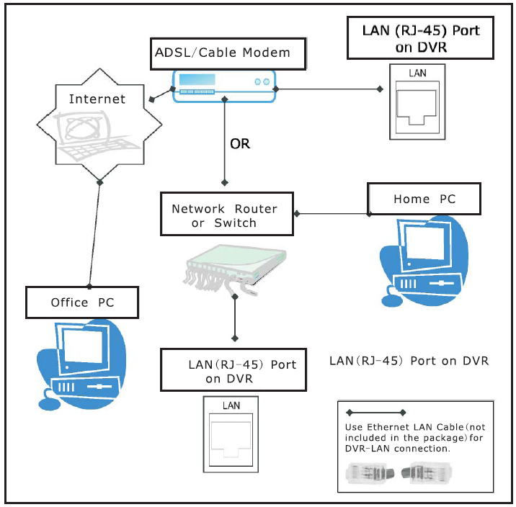
You need to register a www.dyndns.com to get a free account .After registration，you will have a username and password. You can also register your domain name on the website. Please refer to Chapter 5 “Network Setup” for more details. There you will learn how to input the Dyndns username，password，and domain name. You can log in from anywhere by using Internet Explorer and entering your DVR’s domain name.

5.23 Language
You can change the OSD language from the default English to other languages, if your DVR supports multi-languages.
[WWW.DynDNS.com ]
[ ]
[ ]

MAIN MENU

CAMERA SETUP
RECORD SETUP
RECORD FRAMERATE
VIDEO QUALITY NORMAL
RECORD SCHEDULE
SENSOR SETUP
HARD DRIVE SETUP
MISCELLANEOUS SETUP
NETWORK SETUP
LANGUAGE ENGLISH
VIDEO BACKUP
RESET MENU

( )MOVE (SEL)SELECT (MENU)EXIT

( )MOVE (SEL)SELECT (MENU)EXIT

5.24 Video Backup
This function is only available for the model which supports USB memory stick or CD-RW device backup. If your DVR is with PC-link USB interface, please refer Charter 8 for video backup.
Move the cursor to “VIEW EVENTS”, press [SEL] to enter event list. Press [▲] or [▼] button to move the cursor, and then press [SEL] to select the event you like to backup and return to previous menu.
EVENT LIST

00003 T 2008/08/22 19:42:25
00002 T 2008/08/22 17:30:19
00001 T 2008/08/22 16:20:22
00000 T 2008/08/21 17:12:43

The DVR system already indicated the start & end time of the recording event. Move the cursor to “SIZE”, DVR will automatically indicate the size of the video you like to backup to USB memory stick or CD/DVD.
VIDEO BACKUP

VIEW EVENTS
START: 2008/08/22 16:20:22
END: 2008/08/22 16:48:28
SIZE: [197] MB
FILE NAME: [VID000.MCG]
BACKUP TO CD/DVD
BACKUP TO USB DEVICE

( )MOVE (SEL)SELECT (MENU)EXIT

You can directly select the start& end time of a recording video to backup. Move the cursor to “START” or “END”; press [SEL] to enter the interface. Press [◄◄] or [►►] button to move the cursor, and then press [SEL] to modify the value.
Press [MENU] back to previous menu.

BACKUP STARTING TIME

2008/08/22 16:20:22

( )MOVE (SEL)SELECT (MENU)EXIT

You can rename the backup file. Press [◄◄] or [►►] button to select the character you want to modify, press [▲] or [▼] button to select a character from the given character list, and then press [SEL] to enter.
Please note that the name must be ended with “.MCG”.
BACKUP FILE NAME

VIDOOO.MCG
0
1
2
3
4
5
6
7
( ) CHANGE ( )MOVE ( SEL )SELECT
( CH )NUMBER ( )DELETE ( ) INSERT
(MENU)EXIT

VIDEO BACKUP

VIEW EVENTS
START: 2008/08/22 16:20:22
END: 2008/08/22 16:48:28
SIZE: [197] MB
FILE NAME: [VID000.MCG]
BACKUP TO CD/DVD
BACKUP TO USB DEVICE

( )MOVE (SEL)SELECT (MENU)EXIT

Insert your USB memory stick device into DVR’s USB port.
Move the cursor to “BACKUP TO USB DEVICE”, press [SEL] button.

DVR will check your USB device as left picture showed and then start to copy the backup file.

BACKUP TO USB DEVICE

Check USB devices

(MENU)EXIT

Please read Charter 8 on how to play back your backup file.

5.25 Reset Menu
If you select this item, the system will restore all your settings to factory default values. You need to enter your password to reset the menu.

5.26 NTSC/PAL Output select
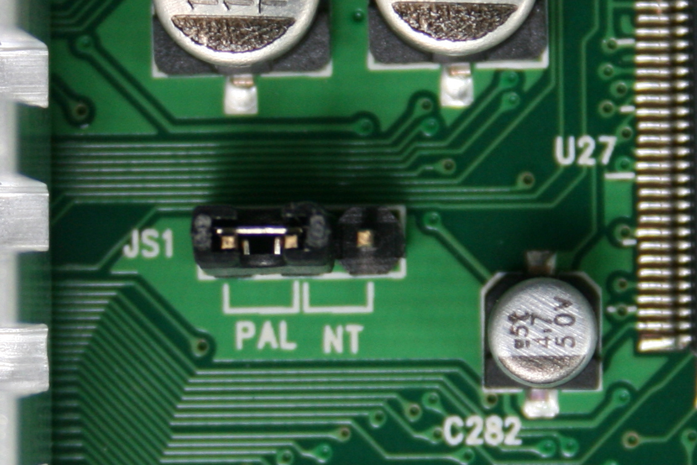
Change the jumper JS1 to select NTSC or PAL video output format according to the silkscreen on the PCB.

Chapter 6: Record

6.1 Start Recording
Press [●] record button to start recording according to the record schedule you have set. System will display some information on screen.
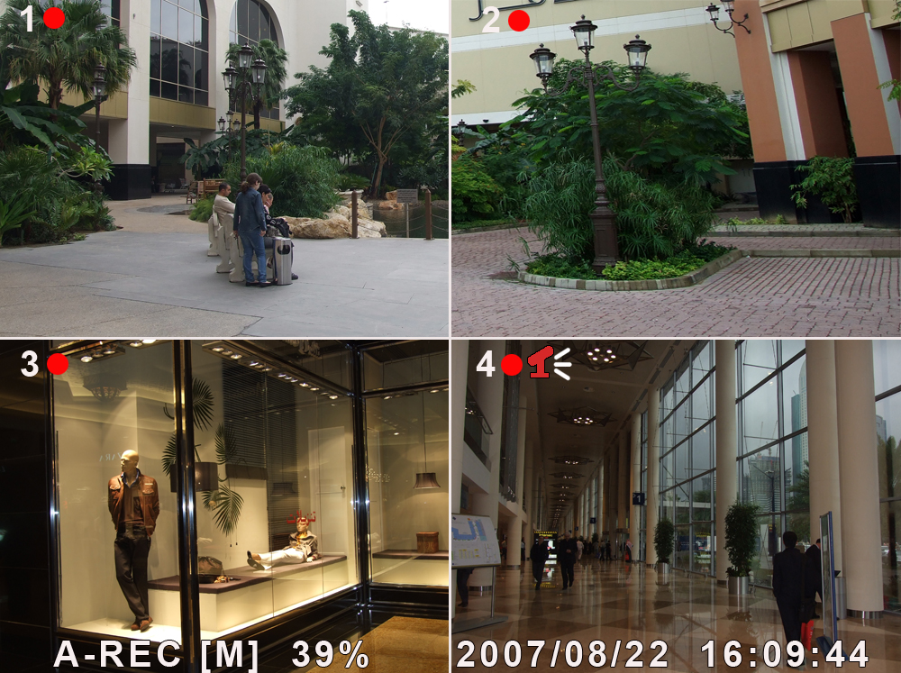

[●]: the red pot next to the channel name indicates that the channel is being recorded.
[A-REC]: indicates the current record schedule is set to NORMAL-RECORD mode.
[S-REC]: indicates the current record schedule is set to SENSOR-RECORD mode.
[N-REC]: indicates the current record schedule is set to NO-RECORD mode.
[39%]: indicates the percentage of hard disk space used.
[M]: HDD info ([M] Master Hard Disk)

6.2 Audio Recording
[]: indicates this video channel is bundled with an audio port, and the audio output is on.
[]: indicates the audio output is off.
[]: indicates the audio is being recorded and the audio output is on.
For 9-channel, you could press [MUTE] button on front panel to be mute mode for audio output. The audio input can be still recorded while the output is mute.
For 4-channel, you could press [DOWN] button on front panel to be mute mode for audio output. The audio input can be still recorded while the output is mute. And you could press [UP] button to switch one of the two audio inputs to live output

6.3 Stop Recording
Press [■] stop button will stop recording. If password protection function is enabled, system will prompt you to input password. Only correct password can stop recording process.

6.4 Estimated Recording Length
Estimated record time based on 160GB HDD
Standard | Quality | 60fps | 48fps | 32fps | 16fps | 1fps
NTSC | Highest | 62 | 78 | 116 | 232 | 3720
NTSC | High | 88 | 110 | 165 | 330 | 5280
NTSC | Normal | 107 | 134 | 201 | 401 | 6420
NTSC | Lower | 120 | 150 | 225 | 450 | 7200

Standard | Quality | 50fps | 36fps | 24fps | 12fps | 1fps
PAL | Highest | 64 | 89 | 133 | 267 | 3200
PAL | High | 90 | 125 | 188 | 375 | 4500
PAL | Normal | 110 | 153 | 229 | 458 | 5500
PAL | Lower | 123 | 171 | 256 | 513 | 6150
Unit: Hour

Chapter 7: Playback

In preview mode, pressing the [►] PLAY button goes into PLAYBACK mode. The newest record event will be played.
Press the [MENU] button during in PLAYBACK mode，then the system will list all the recorded events. The latest record will be on top of the list. Press the ［▲］or [ ▼］ button to select the event and then press [►] to play the event.
SEARCH VIDEO

DISK: MASTER SLAVE [NONE]
08/09/19 11:16:31 - 08/09/19 15:05:48

TYPE: EVENT TIME
PLAY:EVENTS
00006 T 2008/09/19 15:07:40
00006 T 2008/09/19 14:07:40
00006 T 2008/09/19 13:07:40
00006 T 2008/09/19 12:07:40
00006 T 2008/09/19 11:07:40
00006 T 2008/09/19 10:07:40
00006 T 2008/09/19 09:07:40
( )MOVE (SEL)SELECT
( )PLAY (MENU)PREV MENU

SEARCH VIDEO

DISK:MASTER SLAVE [NONE]
08/09/19 11:16:31 - 08/09/19 15:05:48

TYPE: EVENT TIME

PLAY:00006 T 2008/09/19 15:07:40

( )MOVE (SEL)SELECT
( )PLAY (MENU)PREV MENU

Another way to search video is directly input time period. Press the [MENU] button then use [◄◄] or [►►] button to select the TIME search mode. Use [SEL] button to edit time value, press [►] to play the video. If the time you selected has no record event, it will indicates “NO EVENTS” on the screen when you press [►] play button.

Chapter 8: USB Progamming

8.1 Driver Installation:
- Insert driver CD in your CD-ROM Drive.
- Open CD directory.
- Double click on the install applications.
- Run “Install” program.
- Follow the setup wizard to finish the installation.
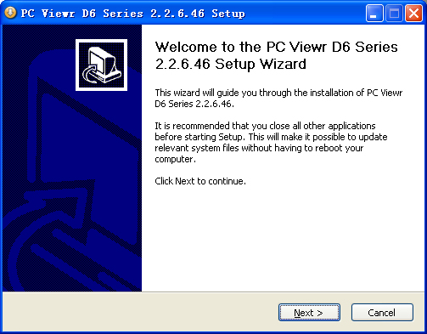

8.2 Program Interface – Button Functions:
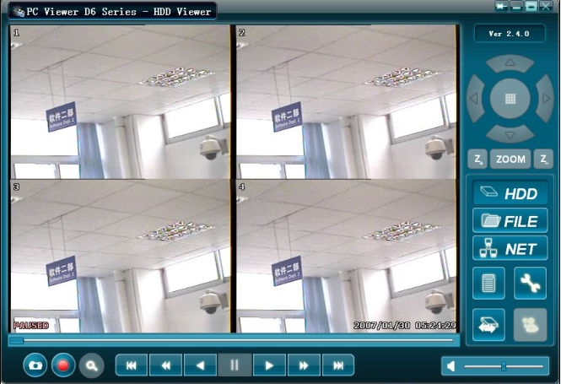
18
10
11
12
13
14
15
16
20
21
17
19
9
8
7
6
5
4
3
2
1

1.PTZ Control | 12. Time Search
2.Zoom in，Zoom Out | 13. Jump back 60s
3.HDD Play Mode | 14. Jump back 10s
4.File Play Mode | 15. Reverse playback
5.Net Play Mode | 16. Pause
6.Event List | 17. forward playback
7.Change DVR settings | 18. Jump forward 10s
8.Remote DVR Control | 19. Jump forward 60s
9.Change Storage Device | 20.Playback Slider
10.Capture Image | 21.Audio Slider
11. Convert Streams to AVI file

8.3 Program Running

8.3.1 HDD play mode

System will detect the HDD automatically when you connect the USB cable to your PC. An USB icon“ ” will appear in the system tray (right bottom corner of the screen). After you’ve seen the USB icon, double click “ ” icon on your desktop to run the program.
Note: if you do not follow above steps, the program will fail to detect HDD
Press “  ” to open the video event lists.
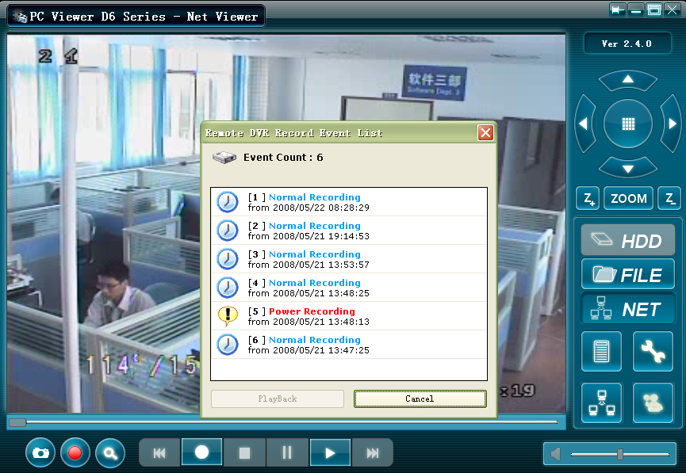
Press “” to configure the program local settings.
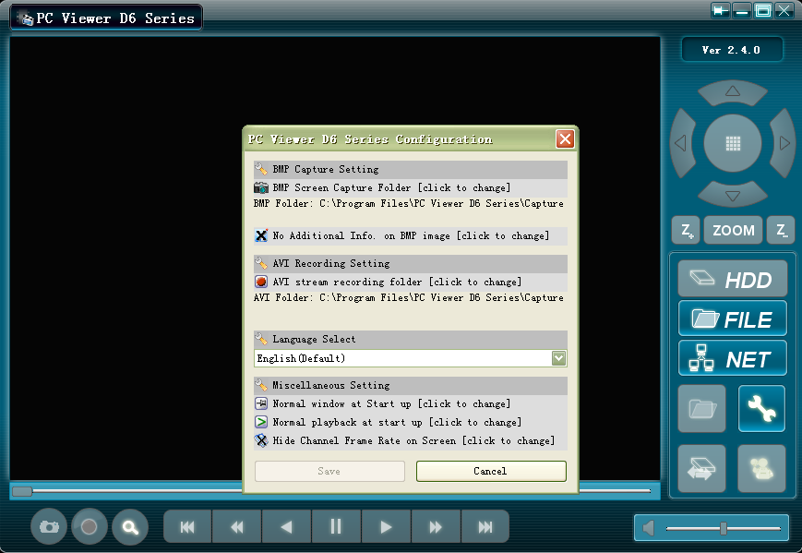

Press “ ” to play video.
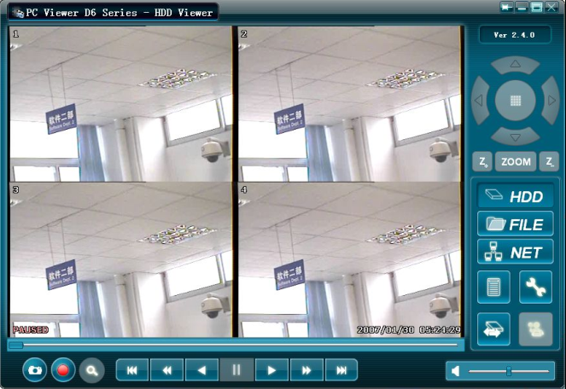

8.3.2 FILE play mode
Press “” to open a folder and select the file you want play. Double click the file.
Note : This function is only used to play the backup files on USB or CD/DVD device.
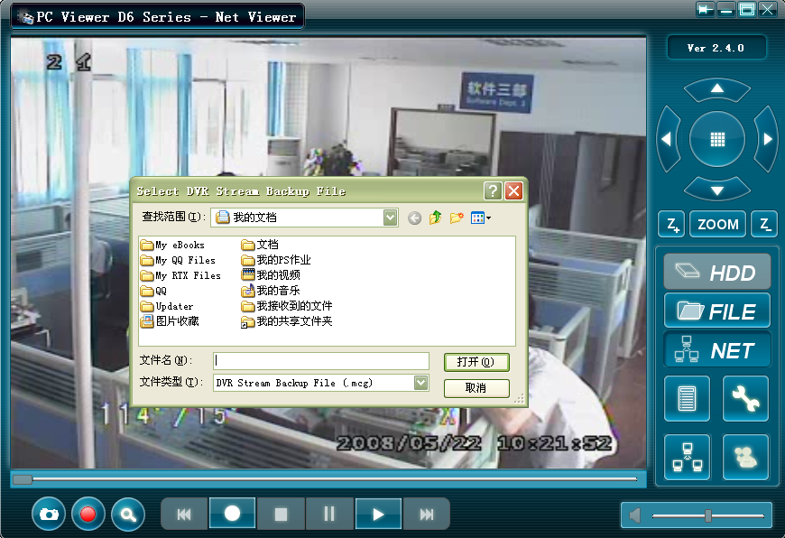

8.3.3 NET play mode
This mode allows you to remote control your DVR via Internet or Intranet. Press “” to pop up the login window. Fill in Host Name, Host Port, User Name and Password of the DVR that you want remotely access and then press Login to enter the main page.

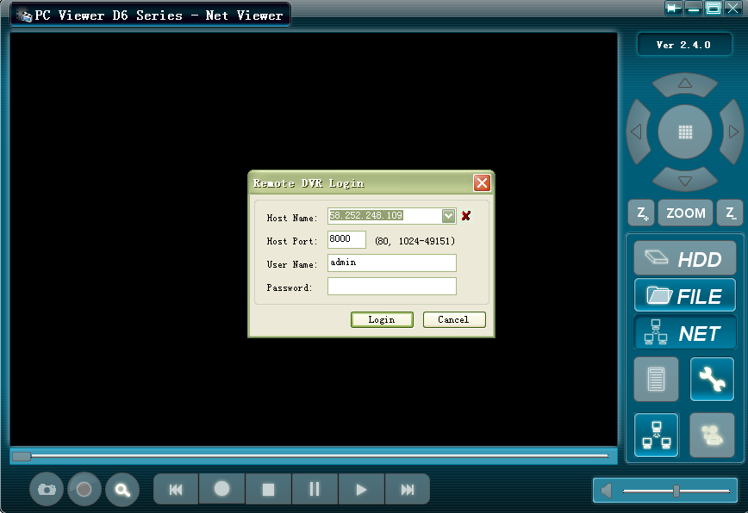

Chapter 9: Specification

4 / 9-Channel DVR
Items | Descriptions
Video Standard | NTSC/PAL
Video Input/Output | 4 Channels/2 Channels，9 Channels/1 Channel
Audio Input/Output | 2 Channels/2 Channels，1 Channel/1 Channel
Monitoring | Resolution | NTSC:720X480@30fps(Each Ch)  PAL:720X576@25fps(Each Ch)
Monitoring | Features | Full-D1，1-CH/4-CH/9-CH Display
Recording | Resolution | NTSC:720X240@60fps(4/9Ch.Total)  PAL:720X288@50fps(4/9Ch.Total)
Recording | Features | Variable Frame Rate/Variable QL per Channel
Recording | Quality | 4-Level(Highest, High, Normal, low)
Audio | ADPCM2 CODEC
Video | MPEG-4
Motion Detection | Settable Window/Level
Microprocessor | 32-bit RISC Processor
Network Interface | TCP/IP(RJ45)
Network Monitor | IE(Internet Explorer) PC Viewer Software
PTZ Interface | RS-485
USB Interface | USB 2.0
VGA Output | Optional
Remote control | IR remote control

Chapter 10: Appendix

10.1 System connection diagram
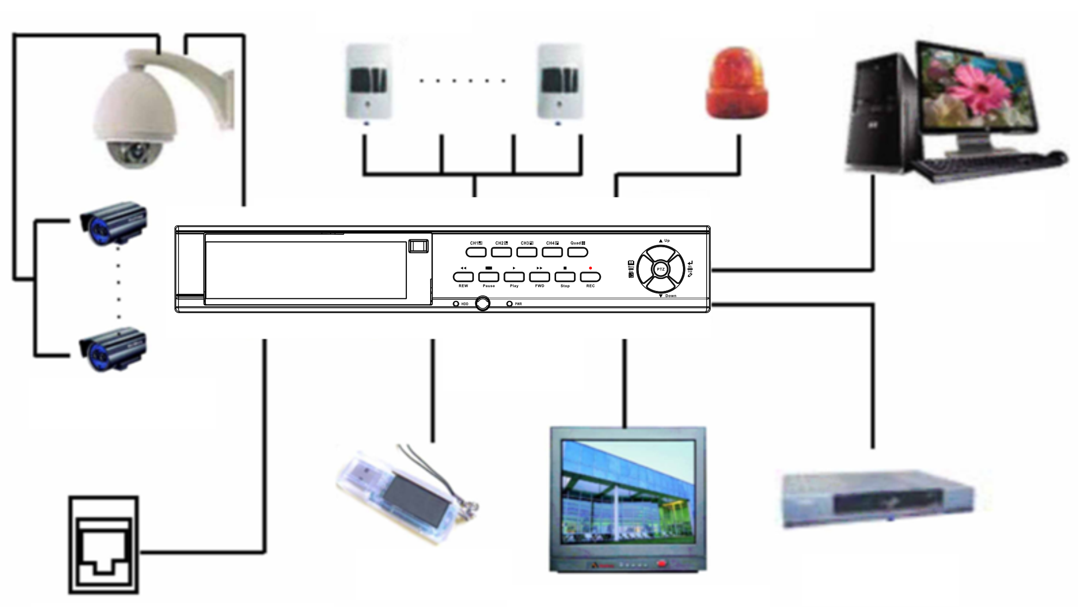
LAN(RJ-45)Port on DVR
Camera
Sensor
Alarm
PC(Optional)
VCR
TV or Monitor
USB
DVR

10.2 Accessories
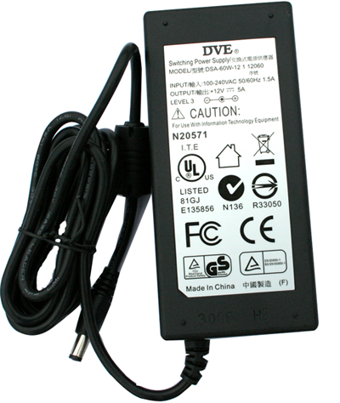
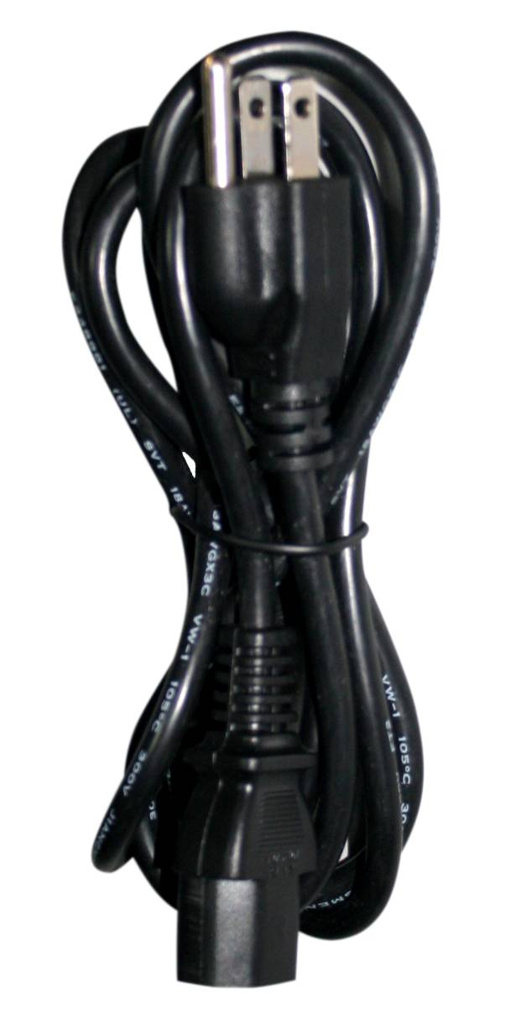
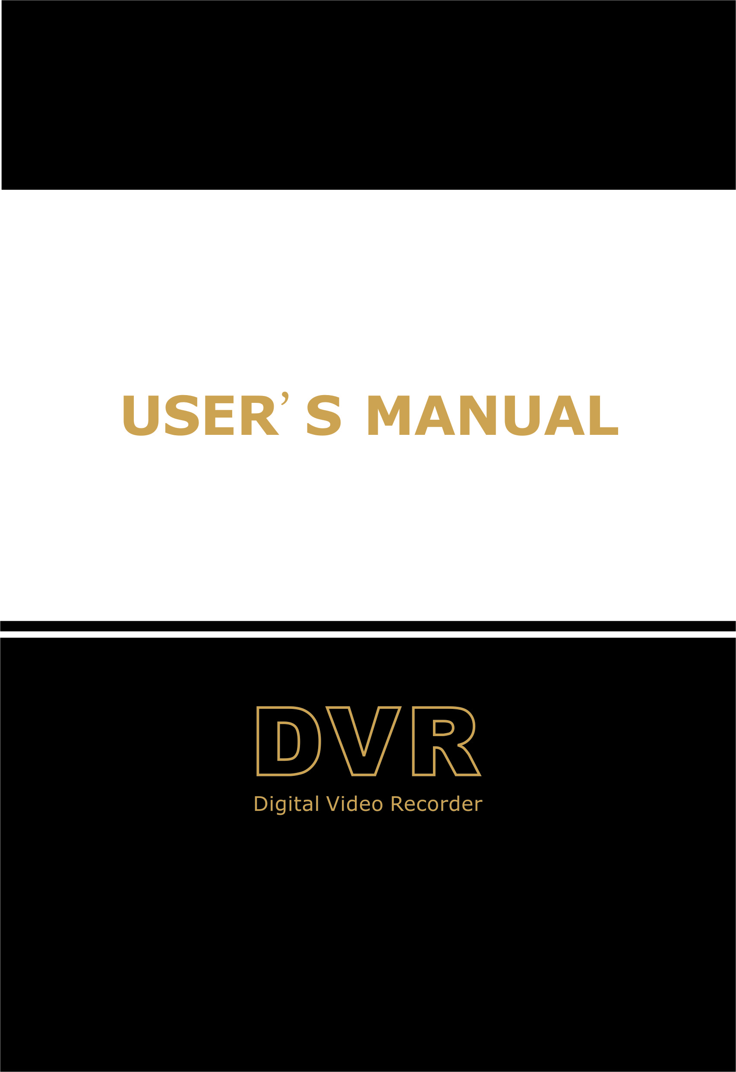

Power Cord
Design may vary depending on country
Power Adaptor
User’s Manual

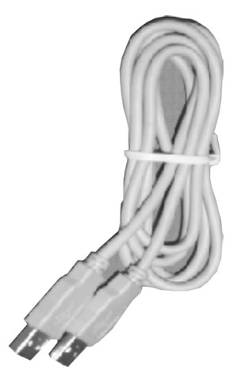
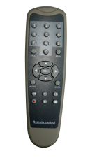
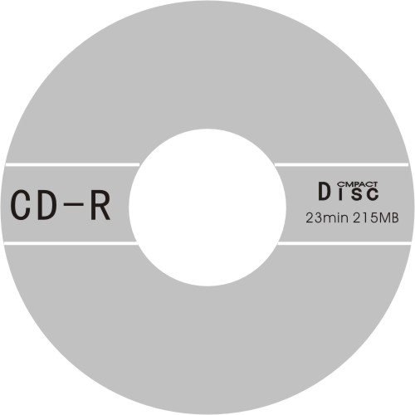

Software CD
Remote Controller
USB Cable (For PC Backup Only)

China prints 2008.6
V1.0

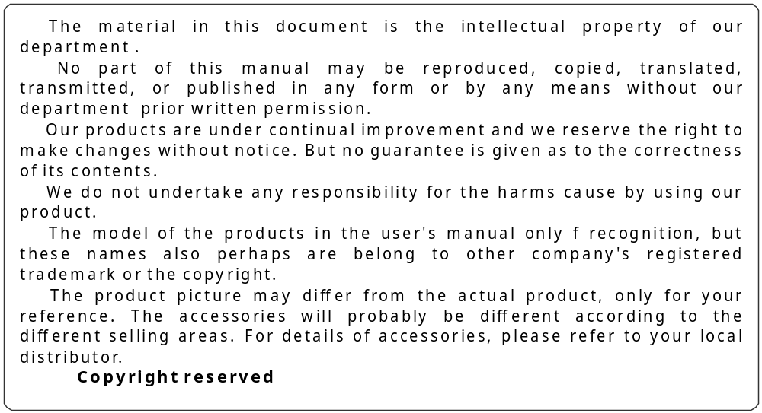

Product Registration Card
Product Name:____________________ Product Model NO.: _________________________
Date of Purchase: __________________Invoice NO.: _______________________________
User Name :______________________ FAX:______________________________________
Telephone: _________________________________________________________________
Address:____________________________________________________________________
E-MAIL: ___________________________________________________________________
Franchiser or exclusive sales agent: ______________________________________________

